Homework Four: Essentials of Linguistics Syntax Continued (6.4-6.5)

Exercise 1.

Identify the type of functional/closed class word underlined in each sentence (Determiner, Pronoun, Preposition). Remember that some of these words can fit into more than one category. So you must identify how it is functioning in THIS sentence.

- I knew I wouldn’t like this movie.
  - Determiner
- I just couldn’t stand it.
  - Pronoun
- I was followed home by a stray dog.
  - Preposition
- Some people just want to watch the world burn.
  - Determiner
- This is completely unacceptable.
  - Pronoun
- I hid under my covers.
  - Preposition

For each of the four practice sentences below, identify the part of speech and phrases in the table. Then, add a sentence diagram below. You can complete your diagrams in my diagraming app and copy your answers into the homework or you can draw them by hand and bring them to class. You can find examples of how to diagram all the unit one structures in the Unit One Diagramming Handout on Canvas. I put each practice sentence on a different page to give you room to diagram.
Example
Phrase | NP |  | VP | PP
WORD | Our | horse | rests | on | the | weekend
Part of Speech | Det | N | V | Prep | Det | N

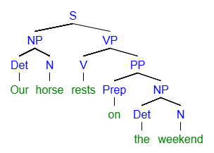
[S [NP [Det Our] [N horse]] [VP [V rests] [PP [Prep on] [NP [Det the] [N weekend]
Practice One
PHRASE | NP | VP |  | PP
Word | Bears | seldomly | attack | without | a | very | good | reason
Part of Speech | N | Adv | V | Prep | Det | Adv | Adj | N

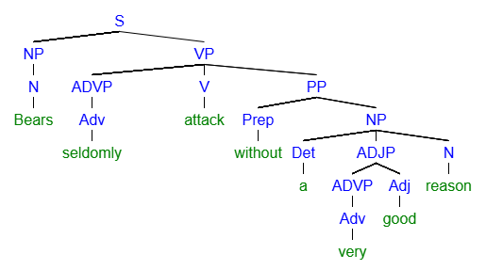
[S [NP [N Bears]] [VP [ADVP [Adv seldomly]] [V attack] [PP [Prep without] [NP [Det a] [ADJP [ADVP [Adv very]] [Adj good]] [N reason]
Practice Two
PHRASE | NP | ADVP | VP | ADVP | PP
Word | Stephen | usually | sits | alone | at | home
Part of Speech | N | Adv | V | Adv | Prep | N

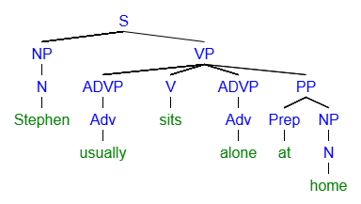
[S [NP [N Stephen]] [VP [ADVP [Adv usually]] [V sits] [ADVP [Adv alone]] [PP [Prep at] [NP [N home]

Practice Three
PHRASE | NP |  |  | VP | PP
Word | My | younger | brother | works | for | the | city
Part of Speech | Det | Adj | N | V | Prep | Det | N

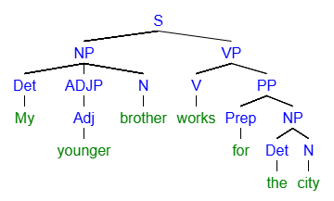
[S [NP [Det My] [ADJP [Adj younger]] [N brother]] [VP [V works] [PP [Prep for] [NP [Det the] [N city]
Practice Four
PHRASE | NP |  |  |  | VP |  | PP
Word | The | painfully | long | discussion | continued | incessantly | until | noon
Part of Speech | Det | Adv | Adj | N | V | Adv | Prep | N

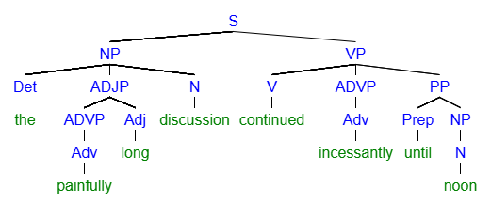
[S [NP [Det the] [ADJP [ADVP [Adv painfully]] [Adj long]] [N discussion]] [VP [V continued] [ADVP [Adv incessantly]] [PP [Prep until] [NP [N noon]
Example Five
PHRASE
Word | All | my | dearest | friends | from | highschool | suddenly | left
Part of Speech | Det | Det | Adj | N | Prep | N | Adv | V

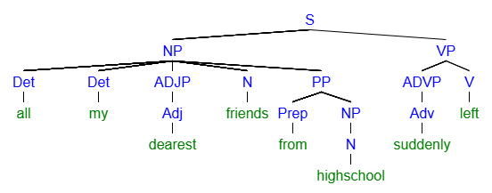
[S [NP [Det all] [Det my] [ADJP [Adj dearest]] [N friends] [PP [Prep from] [NP [N highschool]]]] [VP [ADVP [Adv suddenly]] [V left]

